
Steels for Gears Applications

INSTRUCTORS:
Patrik Olund
Email: Patrik.olund@ovako.com
Hans-Willi Raedt
Email: DrRaedt@prosimalys.de

COURSE INFORMATION

Course Description
Gain a basic understanding of steel and its properties. Learn to make use of steel properties in an application and understand the potential that different steel and heat treatment options can offer. Explore how performance of the material depends on how the steel is produced.

It is recommended that you spend a minimum of 1 hour reading and reviewing the material each day.

Who Should Attend
The course is intended to support gear engineers, gear designers, material specialists or metallurgists at OEMs, Tier 1s, Tier 2s, etc., production engineers, technicians and managers.

Learning Objectives
- Describe how material properties affect by steel quality and heat treatment.
- Describe how stresses are introduced by heat treatment process and surface modification treatments.
- Explain how to select a steel and heat treatment combination to meet the demands of the application
- Review influence of material selection on the manufacturing of components
- Discuss how to verify and specify required steel properties

The training will be a mix of presentations and workshop activities. Discussions during the presentations are encouraged. The training will end with an electronic diagnostic so please bring mobile phone, tablet or laptop to the training.

Required Textbooks
Textbook will be provided by AGMA

COURSE OUTLINE
- Basic introduction to steel in fatigue applications

- Matching the applied load with material strength and residual stresses.

- Examples of standards – from a material perspective

- Strength of material – a combination of composition and heat treatment.

- Heat treatment and surface enhancement processes

- Fatigue – controlled by defects in high strength steel

- Steel making and metal working – how to control defects in steel

- Quantification of steel – old and new methods

- Manufacturing – How different steel types and qualities affect the manufacturing

- Summary – looking at the whole process from design to manufacturing

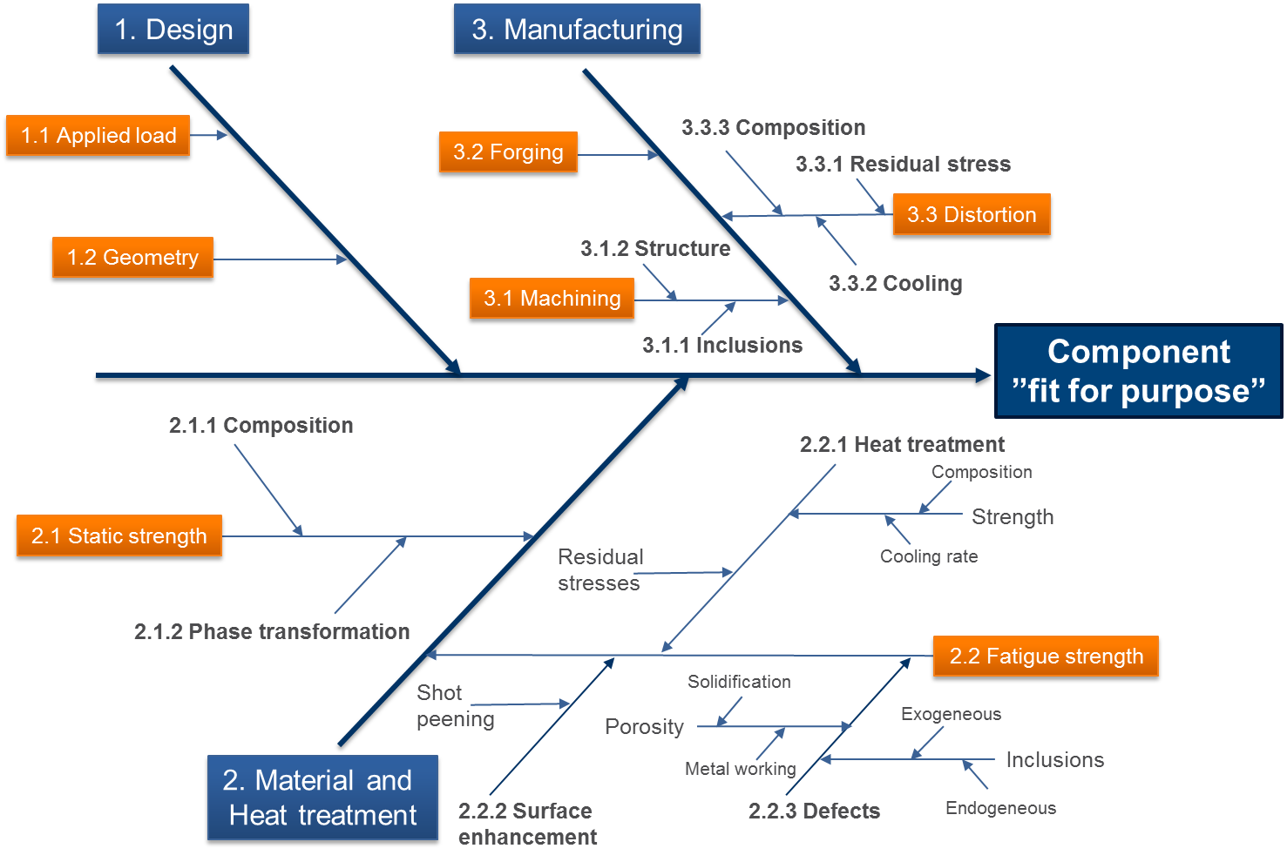

STUDENT FEEDBACK AND GRADING PROCEDURES

Assignments
A Pre-test and post-test are administered during this course. Immediate feedback is given and the material is reviewed by the instructor.

COURSE MANAGEMENT
COURSE MANAGEMENT
Weather Delays and Cancelations
We will communicate any cancellations, delays or other concerns for safety prior to class via email, voicemail, and/or text message. Please be sure that we have all pertinent contact information as you travel to your class location.

Attendance for Domestic and International Students
Please be mindful that these are short, accelerated courses. Attendance is extremely important. If you are going to be absent from any class day, please contact the course coordinator.

Plagiarism, Cheating and other types of Misconduct
Plagiarism, cheating and other types of misconduct are unacceptable.

Students with Disabilities
Students requiring assistance and accommodation should complete the Special Accommodation Request form and submit it to Stephanie Smialek, Education Manager at smialek@agma.org. She can be reached at 773-302-8026.
Grievance Procedures
Students who have concerns about the class are encouraged to contact Stephanie Smialek, Education Manager, at smialek@agma.org or 773-302-8026.
Outline Changes
The instructor reserves the right to modify the outline during the course of the class.
LEARNING AND OTHER RESOURCES
Links for writing resources:
- grammar.ccc.commnet.edu/grammar
- www.merriam-webster.com

Links for Math resources:
- www.sosmath.com
- Khan Academy on www.youtube.com

Links for time management, study skills and note taking resources:
- www.mindtools.com
- www.testakingtips.com

Links for career resources:
- https://www.agma.org/newsroom/jobs/

Industry News:
- https://www.agma.org/newsroom/industry-news/

Plagiarism is defined as “the use or close imitation of the language and thoughts of another author and the representation of them as one’s own original work.”

